Assignment No. 2
High-Level Use Cases
University Timetable Optimization and Management System
Course | Software Engineering
Document Type | Use Case Assignment
Project | University Timetable Optimization and Management System
Prepared For | Submission / project documentation

Prepared using the project brief, the uploaded example structure, and the compiled prerequisite research.

1. Introduction
This document presents the high-level use cases of the University Timetable Optimization and Management System. The system is intended to manage timetable-related data, define rules and preferences, generate schedules, review timetable quality, support controlled changes, and publish final timetables for end users.
The use cases are kept at a high level to match software engineering assignment style. Each use case includes the actor(s), type, essential goal, real-world meaning, and a concise description. Detailed event flows can be written later as expanded use cases if required.

2. System Boundary and Scope
The system boundary covers timetable administration, timetable viewing, room/resource reporting, and controlled timetable modifications. The first version assumes one academic term and a weekly timetable for courses, sections, teachers, and rooms.
• course and section timetable management
• teacher and room data management
• calendar and holiday management
• constraint and preference definition
• timetable generation, review, and publication
• controlled repair after teacher or room changes

3. Actors
Actor | Type | Responsibilities
Timetable Administrator | Primary | Maintains data, defines rules, generates timetables, reviews conflicts, applies changes, and publishes final schedules.
Department Coordinator | Supporting / supervisory | Helps maintain academic data, reviews constraints, and requests timetable changes when needed.
Teacher | Primary end user | Views assigned timetable and may request a change due to availability or special needs.
Student | Primary end user | Views the timetable of the assigned class, section, semester, or student group.
Facility Manager | Supporting actor | Reviews room/resource utilization and related reports.

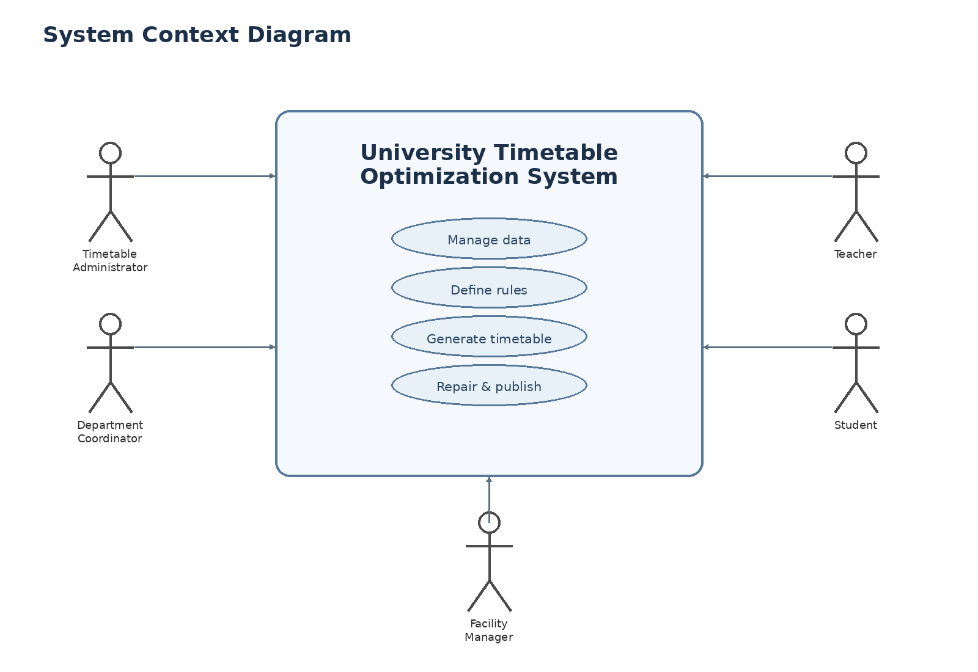
Figure 1. System context diagram of the timetable system.

3.1 Diagram Description – System Context Diagram
The context diagram shows the timetable system as a single software boundary interacting with five external actors. The Timetable Administrator and Department Coordinator interact with the system mainly to manage data and rules. Teachers and students access the system to consume the final timetable and to support controlled change handling. The Facility Manager interacts with the system through resource-related reporting. The ovals inside the central system box summarize the core responsibilities of the platform: manage data, define rules, generate timetables, and repair/publish results.

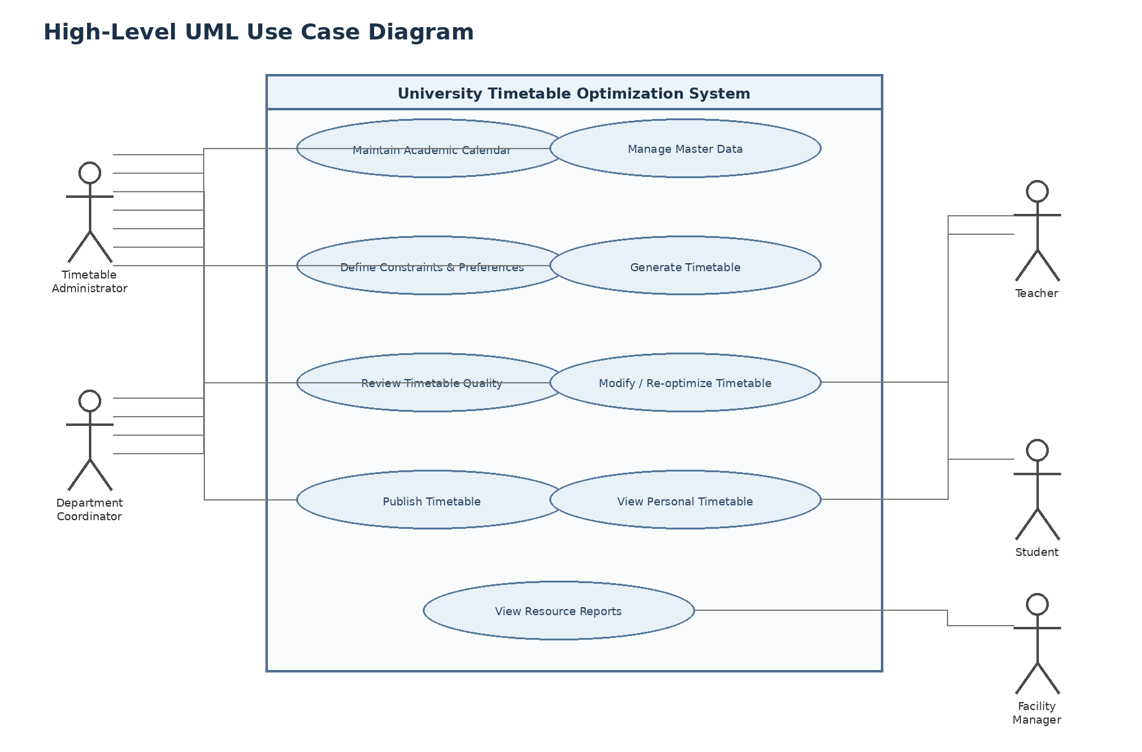
Figure 2. High-level UML use case diagram.

3.2 Diagram Description – High-Level UML Use Case Diagram
The use case diagram presents the main functional services of the system at a high level. The Timetable Administrator is the central controlling actor and interacts with most administrative use cases, including calendar maintenance, data management, rule definition, generation, review, modification, and publication. The Department Coordinator participates in data maintenance, rule discussion, review, and timetable-change activities. The Teacher and Student mainly interact with personal timetable-related functions, while the Facility Manager focuses on room and resource reports. This diagram is intentionally simplified to keep the system understandable at the assignment level.

4. Relationship Notes
Although the diagram is simplified, the use cases still have clear logical relationships. For example, timetable generation depends on previously defined data and constraints; timetable review follows generation; modification and re-optimization occur after review or after a change request; and publication occurs only after the timetable has been accepted.

5. High-Level Use Case Catalogue

UC01 – Maintain Academic Calendar
Actors | Timetable Administrator
Type | Primary
Essential | Define the valid working calendar for timetable generation.
Real | The administrator enters semester dates, working days, holidays, blocked periods, and special closure days before timetable generation begins.
Description | The system stores academic calendar information so that no class is scheduled on invalid dates or blacked-out periods.

UC02 – Manage Master Data
Actors | Timetable Administrator, Department Coordinator
Type | Primary
Essential | Maintain the fixed academic and resource data required for scheduling.
Real | The administrator records departments, programs, courses, sections, teachers, rooms, buildings, capacities, and room features.
Description | The system captures and updates the base entities used later in timetable generation and reporting.

UC03 – Define Constraints and Preferences
Actors | Timetable Administrator, Department Coordinator
Type | Primary
Essential | Specify the rules and policy priorities that will shape the timetable.
Real | The administrator defines hard constraints such as teacher clashes, room clashes, and blocked periods, and soft preferences such as compactness, morning preference, room proximity, and early finishing.
Description | The system stores timetable rules and weight settings so that schedules can be generated according to institutional policy.

UC04 – Generate Timetable
Actors | Timetable Administrator
Type | Primary
Essential | Produce a feasible timetable from the available inputs.
Real | The administrator runs timetable generation and the system assigns classes to time slots and rooms while respecting the configured rules.
Description | The system creates a candidate timetable and saves the generated assignments for review.

UC05 – Review Timetable Quality
Actors | Timetable Administrator, Department Coordinator
Type | Primary
Essential | Inspect whether the generated timetable is feasible and acceptable.
Real | The system displays the timetable, conflict summary, policy satisfaction, and overall quality information so the user can judge the result.
Description | The system presents the timetable together with conflict or quality indicators for decision making.

UC06 – Modify / Re-optimize Timetable
Actors | Timetable Administrator, Teacher, Department Coordinator
Type | Primary
Essential | Change an existing timetable with minimum disruption.
Real | A teacher or coordinator requests a change, and the administrator applies manual adjustments or re-runs timetable repair to preserve as much of the accepted schedule as possible.
Description | The system updates part of the timetable while attempting to avoid unnecessary ripple effects across unrelated classes.

UC07 – Lock Manual Decisions
Actors | Timetable Administrator
Type | Primary
Essential | Protect approved timetable decisions from later automatic changes.
Real | The administrator locks selected room assignments, class placements, or manual overrides before re-optimization is performed.
Description | The system marks selected assignments as fixed so later generation or repair respects them.

UC08 – Publish Timetable
Actors | Timetable Administrator
Type | Primary
Essential | Release the approved timetable for official use.
Real | Once the timetable has been reviewed, the administrator publishes it for students, teachers, and departments.
Description | The system marks a timetable version as official and makes it available to other users.

UC09 – View Personal Timetable
Actors | Teacher, Student
Type | Primary
Essential | Allow end users to view the timetable relevant to them.
Real | Teachers can view their assigned classes; students can view the timetable of their section, batch, or semester.
Description | The system displays a filtered weekly timetable for the selected user or student group.

UC10 – View Resource Reports
Actors | Timetable Administrator, Facility Manager
Type | Secondary
Essential | Review the operational impact of the timetable on rooms and facilities.
Real | The system provides room-wise schedules, room utilization indicators, and summary reporting for resources.
Description | The system shows administrative reports that help evaluate how rooms and facilities are being used.

UC11 – Manage Holidays and Blocked Days
Actors | Timetable Administrator
Type | Secondary
Essential | Record institutional closures and schedule exceptions.
Real | The administrator adds holidays, academic breaks, special event days, and emergency no-class periods.
Description | The system updates the calendar model so those periods are excluded from scheduling.

UC12 – Handle Teacher-Specific Change Request
Actors | Teacher, Timetable Administrator
Type | Secondary
Essential | Process an individual teacher’s scheduling request.
Real | A teacher requests a timetable modification because of availability, leave, or another special reason, and the administrator evaluates the request.
Description | The system stores the request and supports controlled timetable adjustment after review.

6. Use Case Summary Matrix
Use Case | Admin | Coordinator | Teacher | Student | Facility Manager
Maintain Academic Calendar | ✓
Manage Master Data | ✓ | ✓
Define Constraints and Preferences | ✓ | ✓
Generate Timetable | ✓
Review Timetable Quality | ✓ | ✓
Modify / Re-optimize Timetable | ✓ | ✓ | ✓
Lock Manual Decisions | ✓
Publish Timetable | ✓
View Personal Timetable |  |  | ✓ | ✓
View Resource Reports | ✓ |  |  |  | ✓

7. Notes on Scope
• These use cases are intentionally high-level and do not include detailed step-by-step event flows.
• Expanded use cases can later be written for timetable generation, timetable repair, and publication.
• The first version focuses on course timetabling rather than student-by-student personalized scheduling.
• Algorithm selection is deferred to a later phase; this document focuses on functional perspective and system interactions.

8. Conclusion
The high-level use cases define the main scope of the University Timetable Optimization and Management System in a structured and assignment-friendly form. They show who interacts with the system, what the system must provide, and how administrative, operational, and reporting activities relate to timetable management.

9. Reference Notes
This document was prepared from the project brief, the uploaded example structure, and the compiled prerequisite research produced earlier for the timetable project.

